**Exhaustive Analysis of Indian Agriculture using Power BI**

**Step 1:** First go to Microsoft store or google and install Power BI for Desktop app.

**Step 2:** open the power BI app. We get the interface like below.

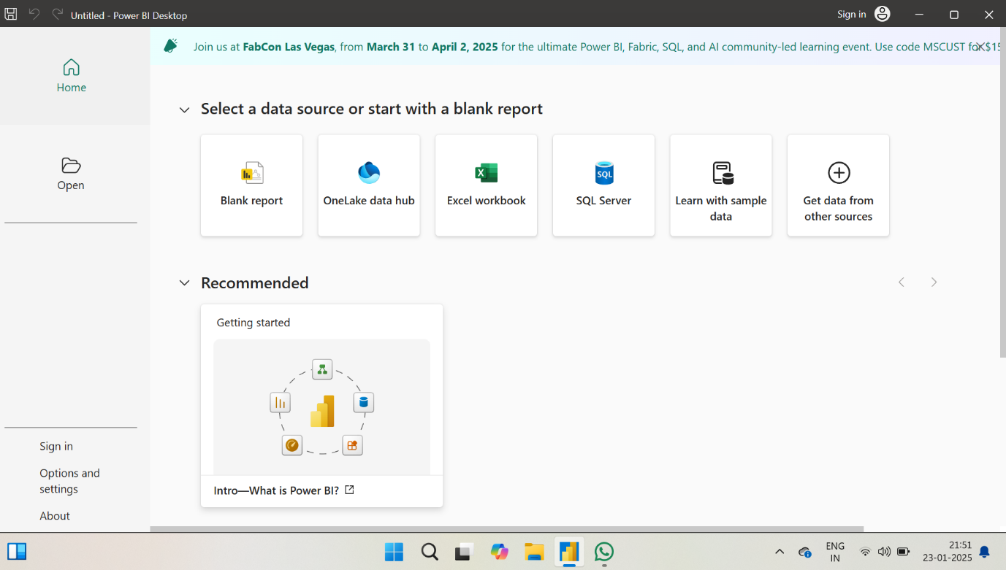

**Step 3:** select the Blank report option. Then we get like this

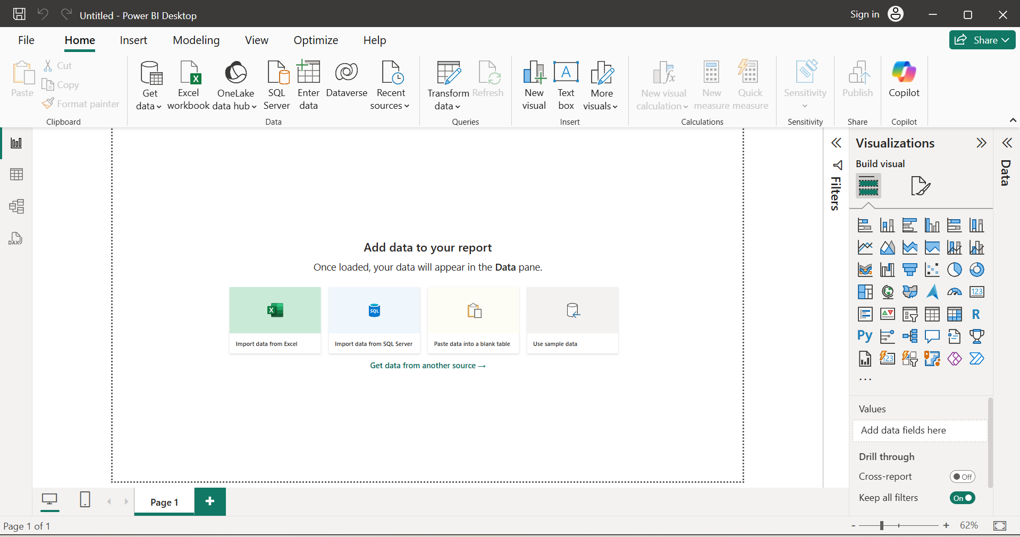

**Step 4:** Nowclick on the get data. Then we get a drop box like below

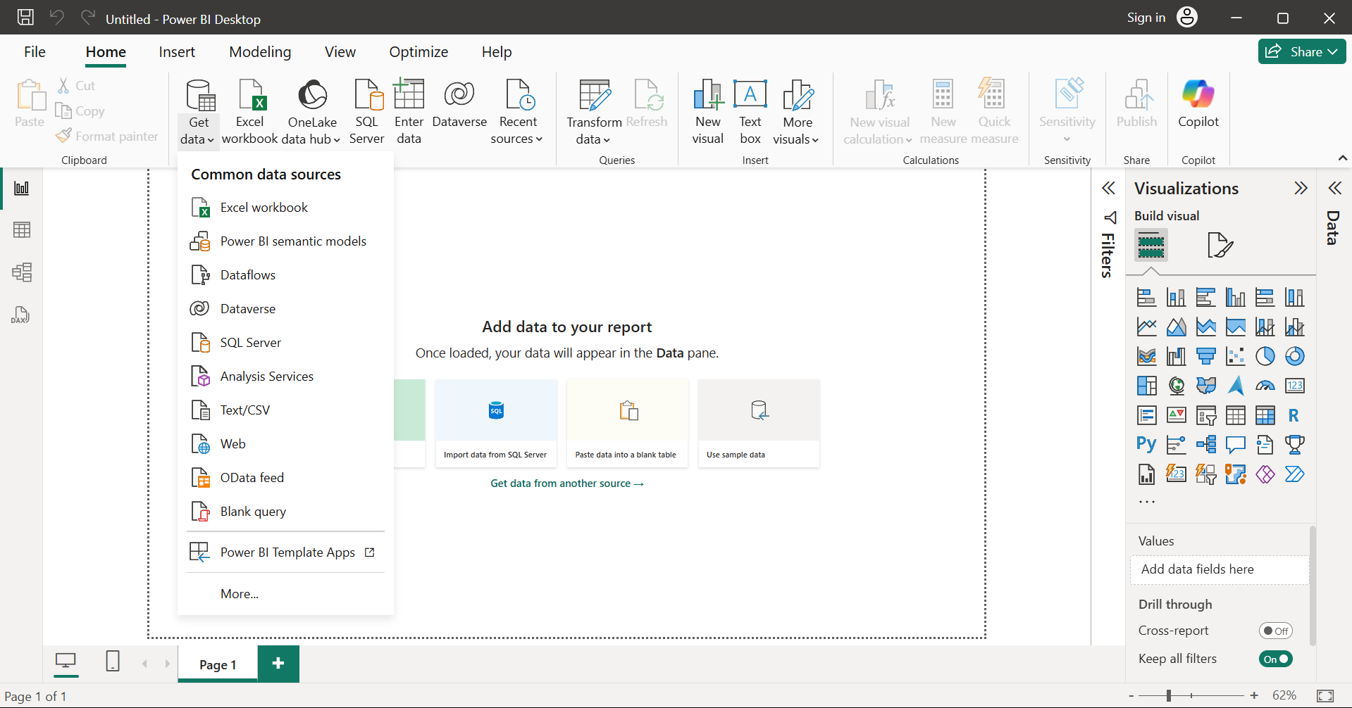

**Step 5:** Then select the option from where you have your data. Here I have my data in csv file so I select Text/CSV option. Then select your file and click open you get the data like below

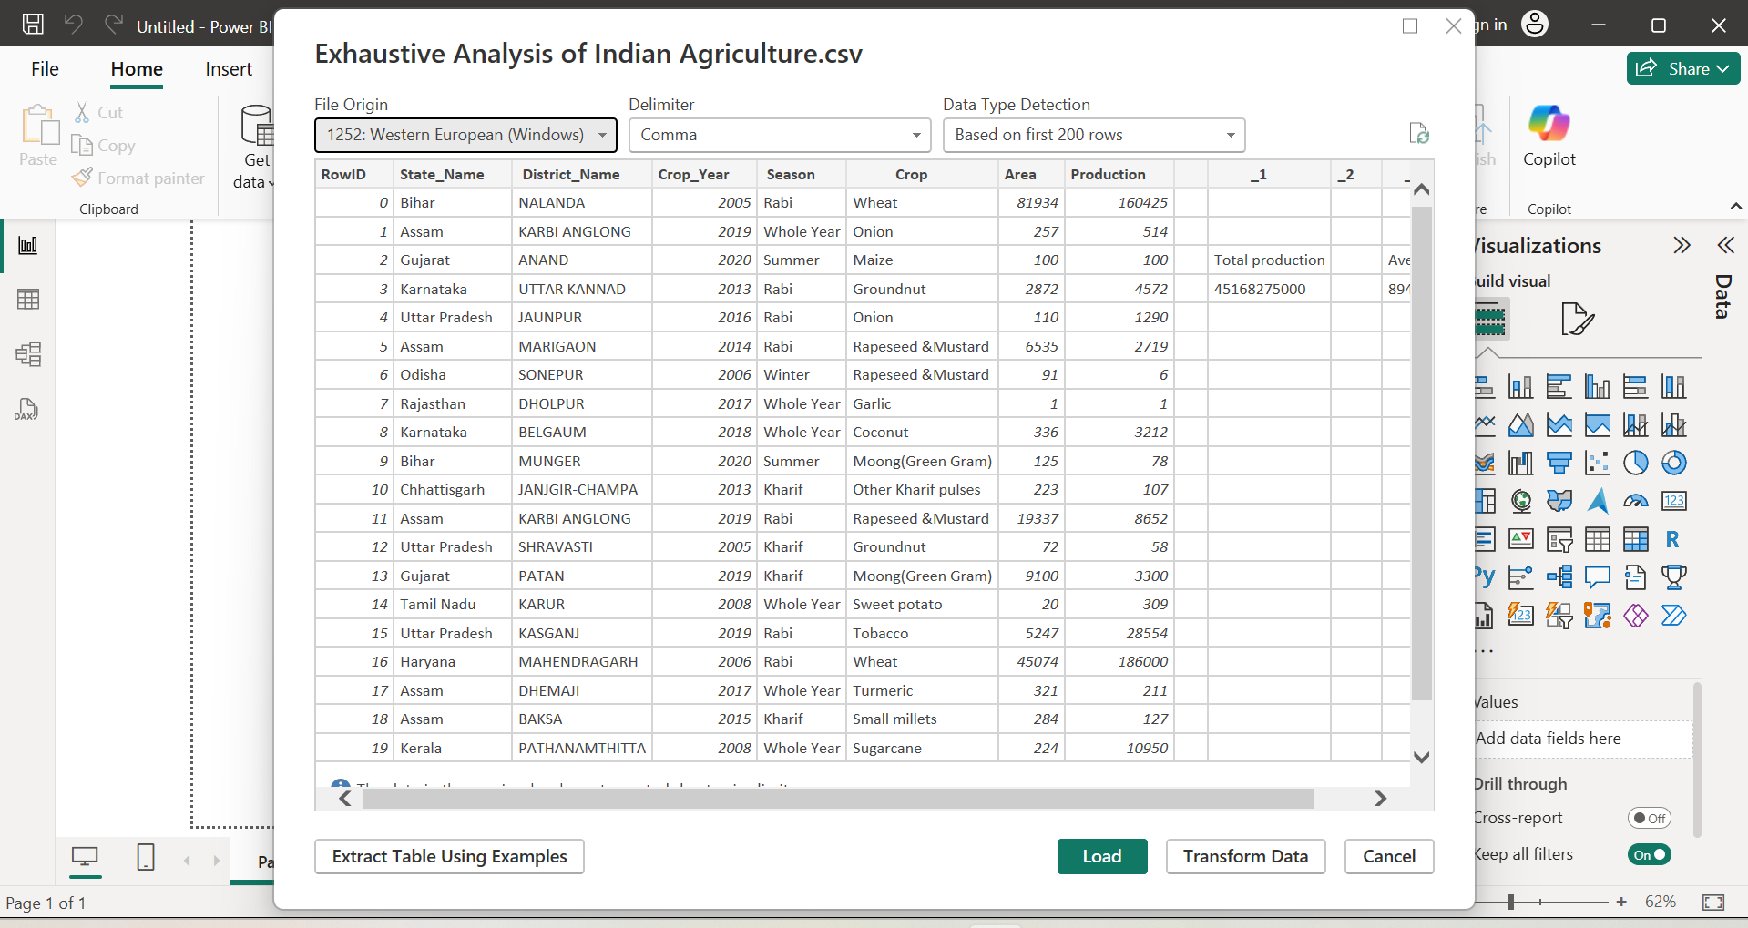

**Step 6:** Then we get 3 options below Load, Transform Data, Cancel. Click on the load option to load data when your data is cleaned. Otherwise you have any changes or to process data click on the Transform data to change. If you select the wrong file click on cancel option.

**Step 7:** After selecting the load option we get the interface like below. You get the file name on the right corner below the copilot option.

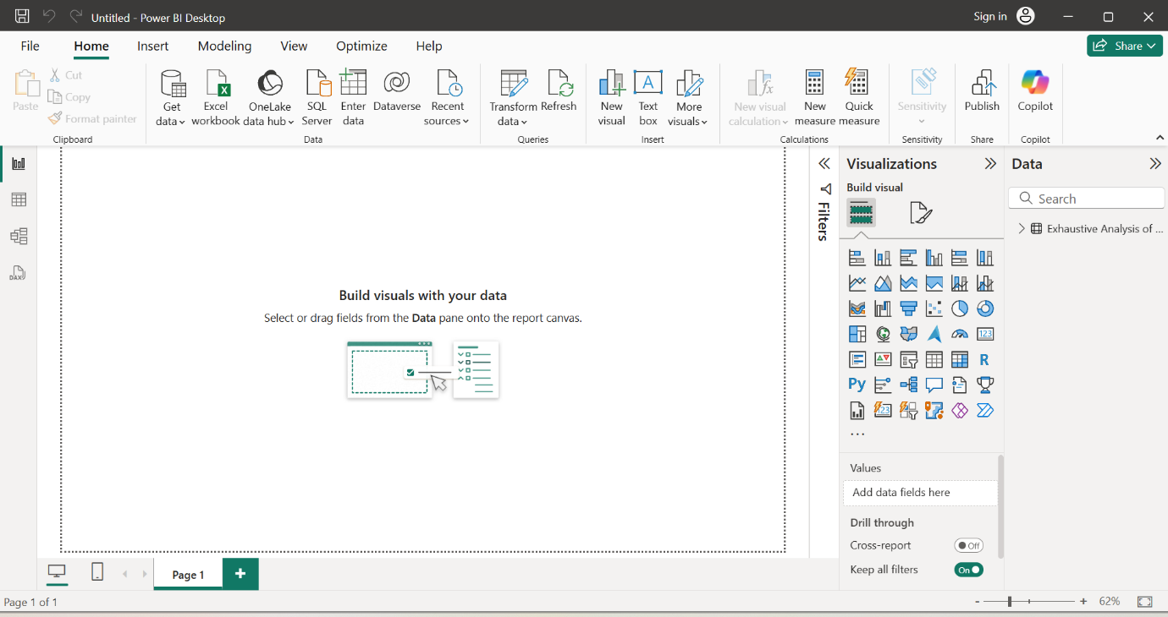

**Step 8:** we get 3 view options (report view, table view, model view) on the left side. report view for visualization, table view to see the data and model view to create relationship among data.

Select the table view option.

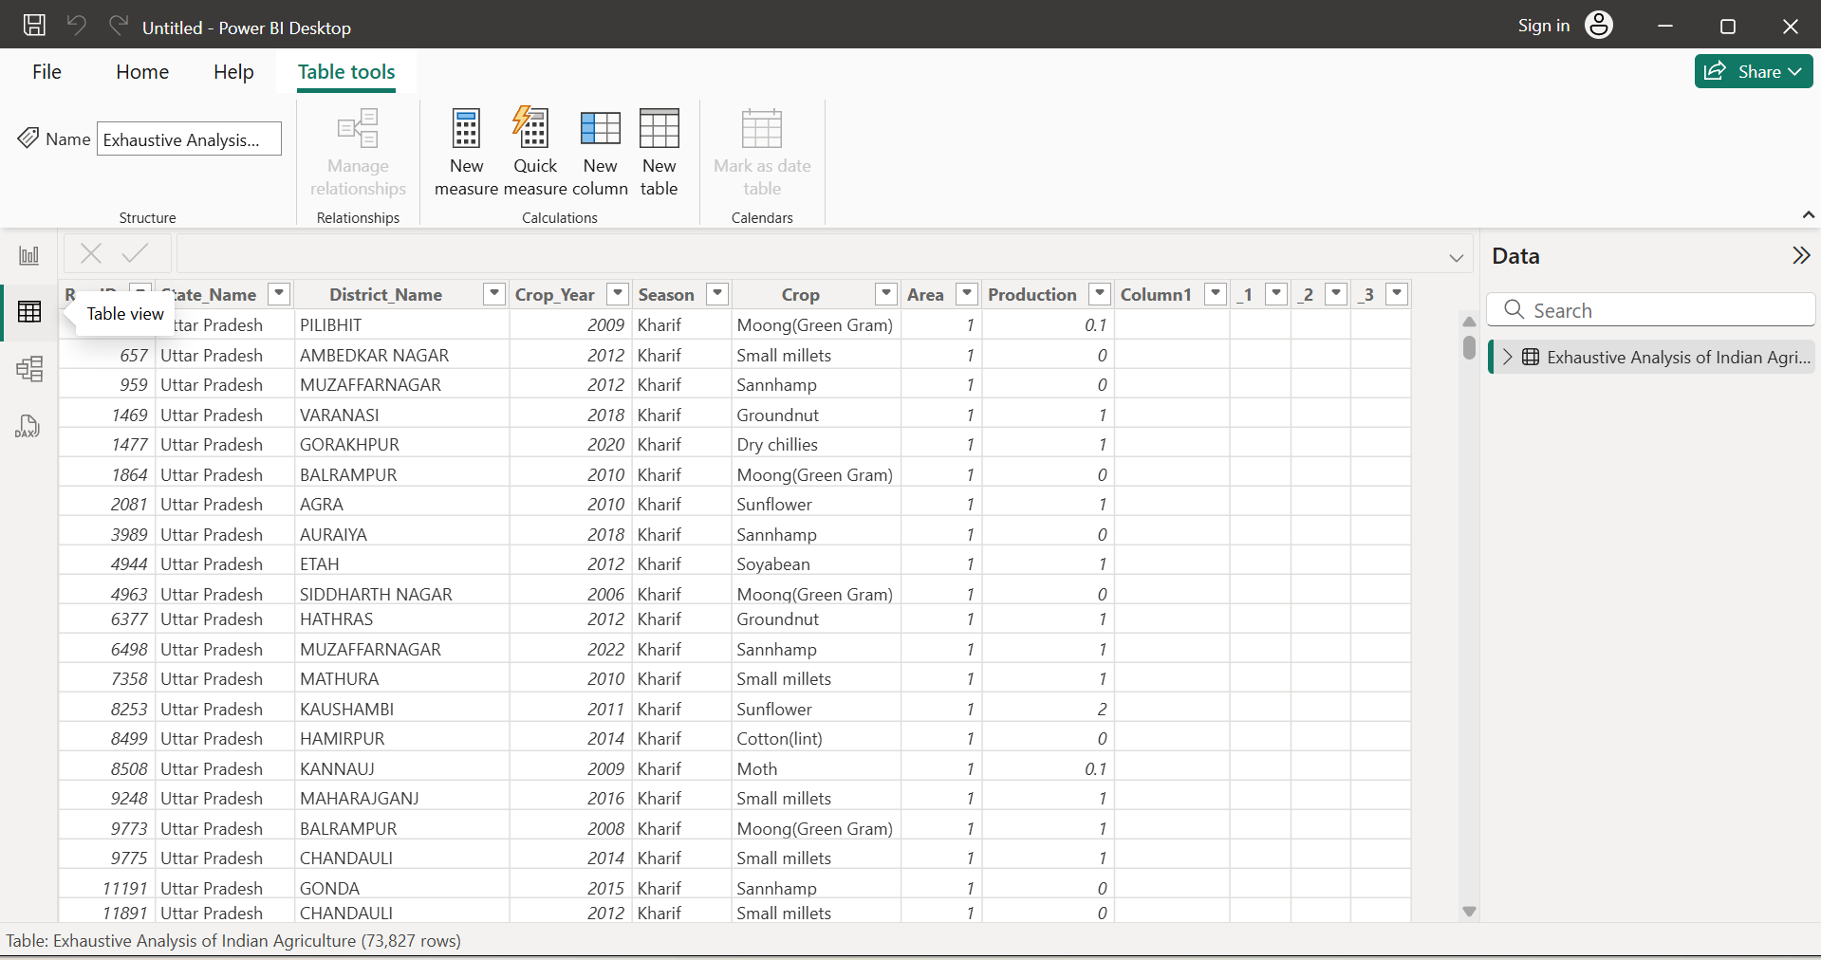

**Step 9:** The model view look like this

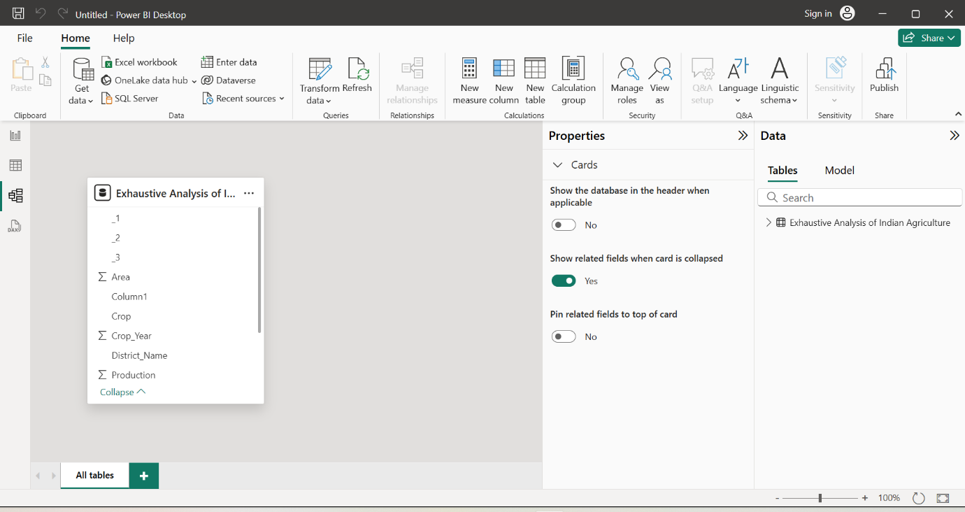

**Step 10:**  Go back to report view and select on transform data option. Then we get a new window power query editor.

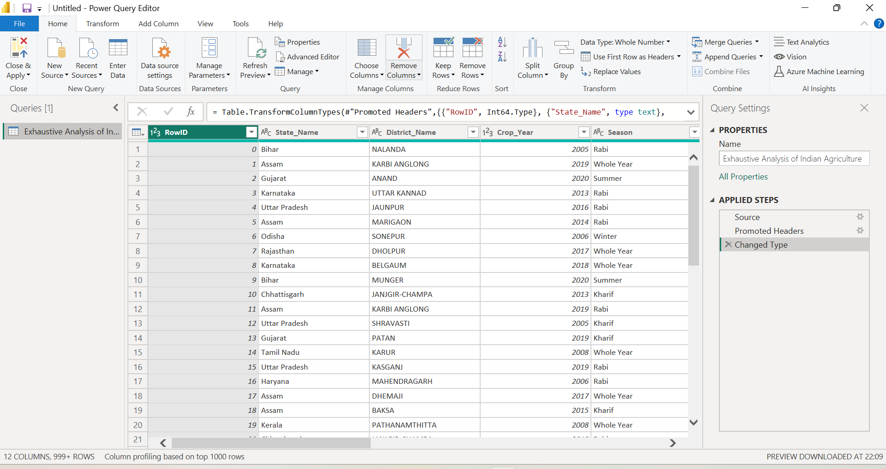

**Step 11:** In this window we can done all the Transformation operations. we can see options in the above picture. If we want to remove any column click on that column we get the options like below.

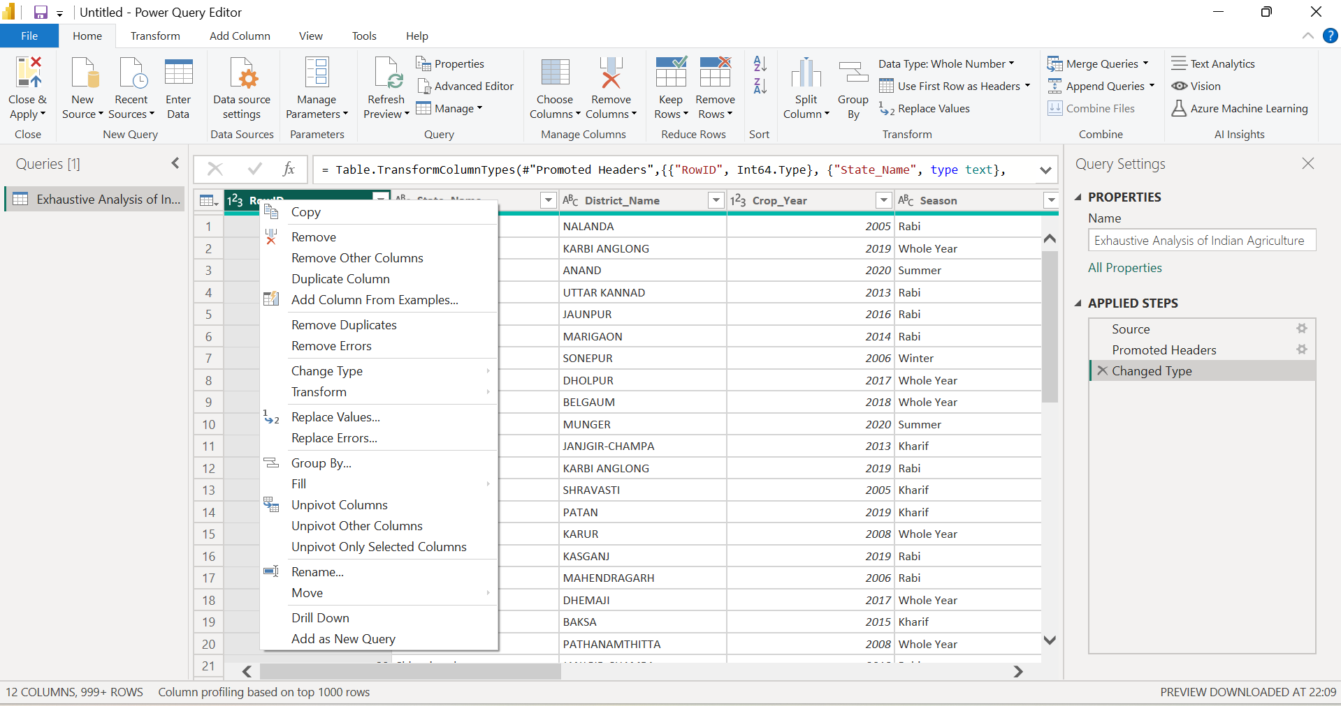

**Step 12:** click on the remove option to remove the column. Then it appear like this

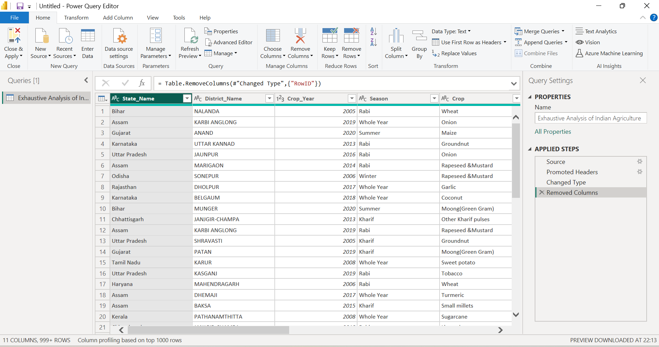

**Step 13:** If you want to get back the column. Click on the Xmark present on the right side of the screen then we get the column back



**Step 14:** Here some of the unwanted columns shown in the below picture. we have to remove the columns by using the above steps.

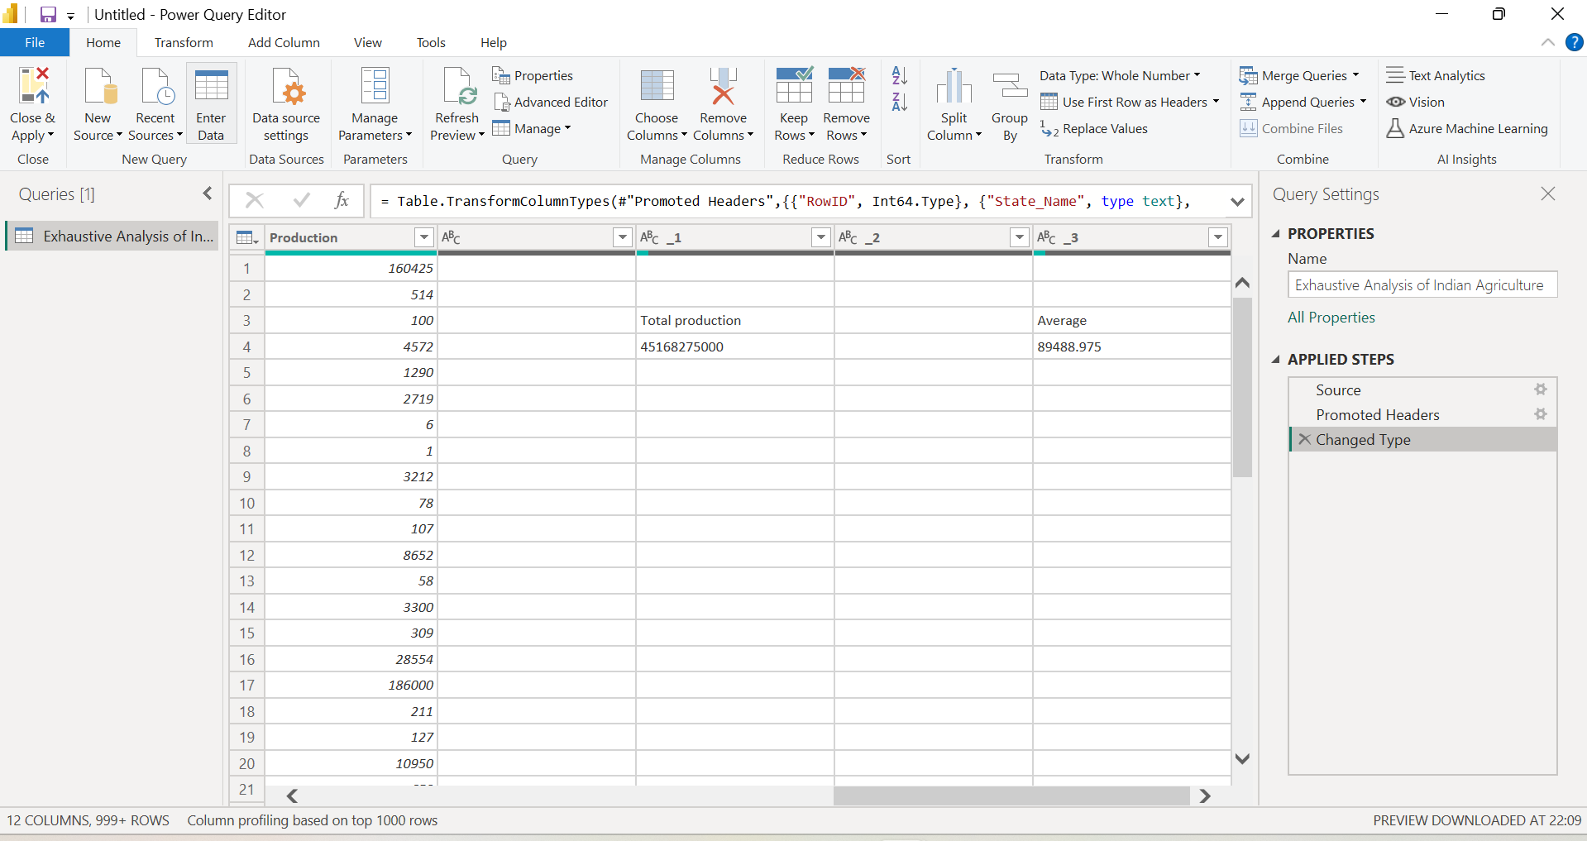

**Step 15:** After removing all the unwanted columns click on the view option and the enable column quality option and we get like below. It gives us the details about the columns.

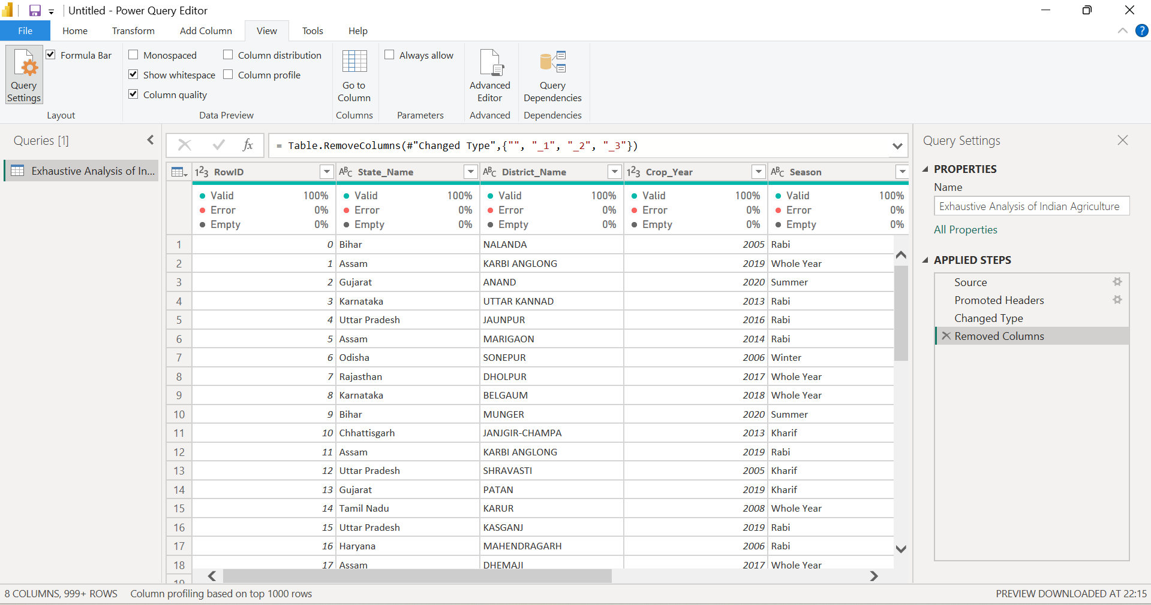

**Step 16:** click on the remove rows option we get the drop down as shown in the picture. To remove any rows which is not required in our data use the options in the drop down .

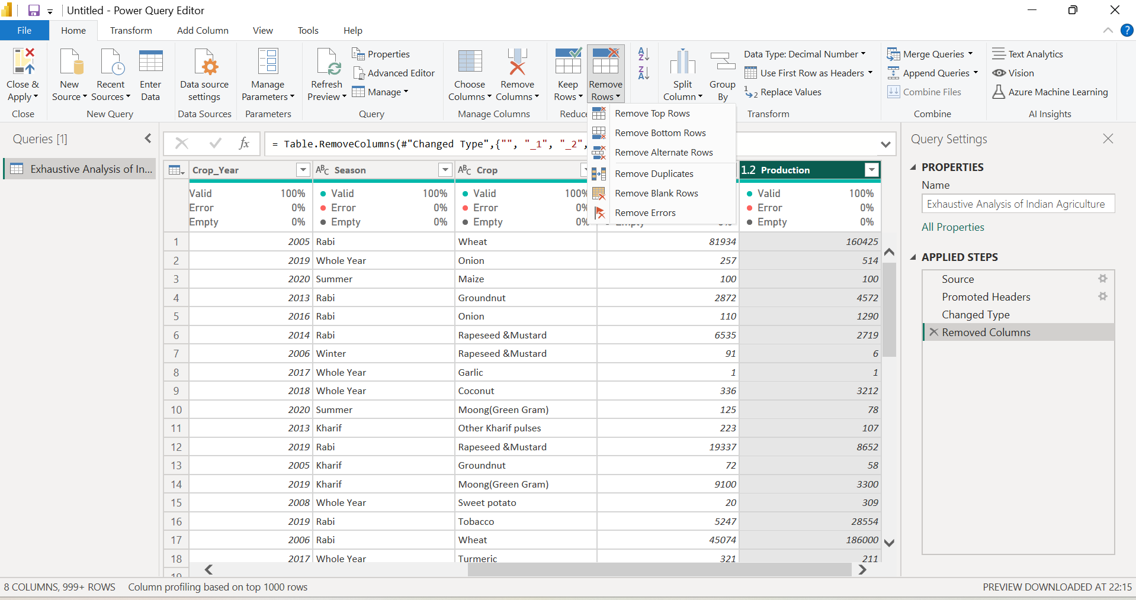

**Step 17:** If we want to change datatype of any column we can change by clicking on the alphabets or numbers present on the left corner of the column. You can understand by seeing below picture.

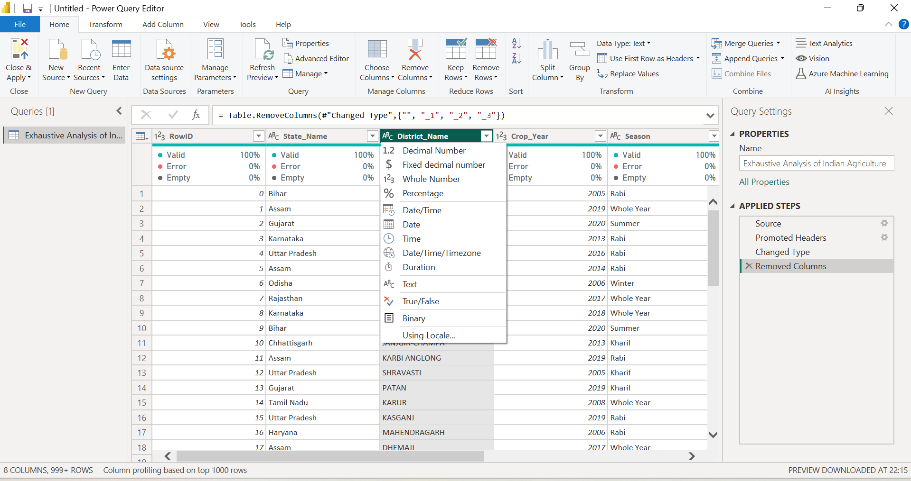

**Step 18:** After doing all the changes required for the data click on the **close and apply** option which is present on the top left of the screen and again select on close and apply then we **get the data to the power BI** with all changes what we done before in the **power query editor.**

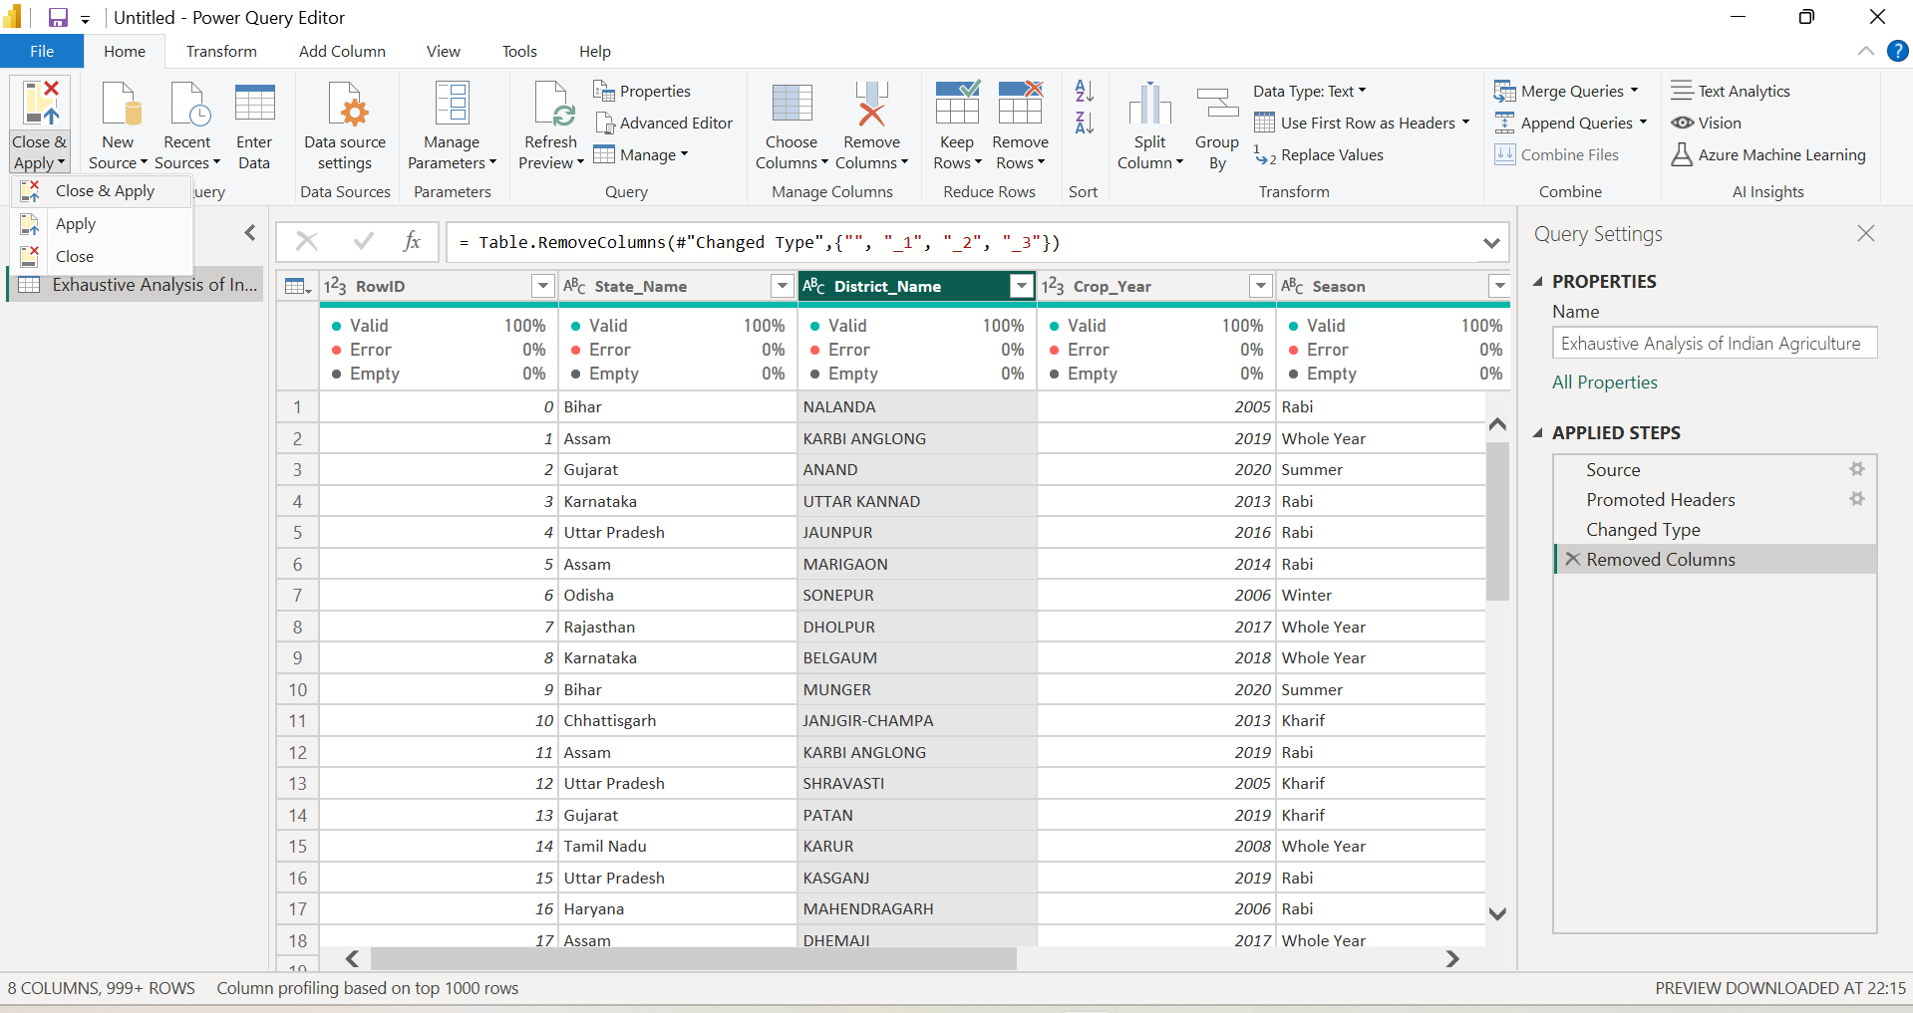

**Step 19:** Finally we get the data in the power BI desktop window table view page like below.

